**Question:**

**Error in question**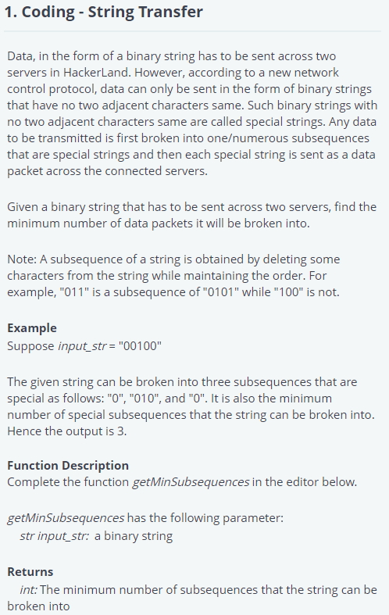

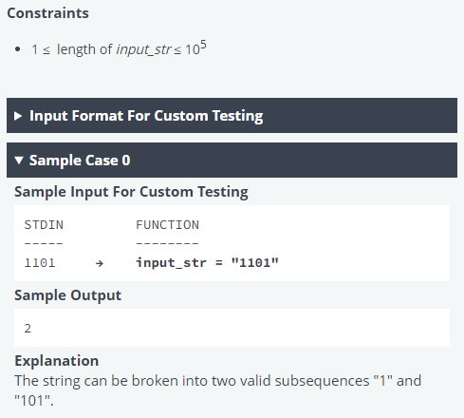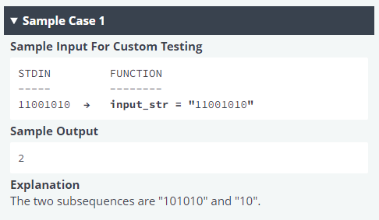

**Answer**

input_str = input()

subsequence = 0

for i in range(0, len(input_str)):

if input_str[i] == input_str[i-1]:

subsequence += 1

print(subsequence)